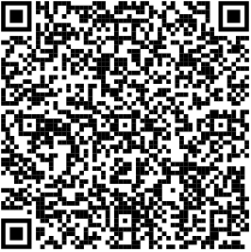
2024 Baseball Tryouts

- Friday January 19th 4:00PM-6:00PM
- Saturday January 20st 9:00AM-12:00PM
- Monday January 22nd If Needed
You must scan and sign up via Google Forms in order to tryout.
If you have questions come find Coach Jensen in room 1502.

